Intertextuality of Suicide Phenomena and the Myth of Pulung Gantung in Gunungkidul, Yogyakarta, in the Short Film Lamun Sumelang

Deby Christi
Petra Christian University, Surabaya, Indonesia
deby.christi@gmail.com

Article Info |  | ABSTRACT
Keywords:  Gunungkidul;  Intertextuality;  Lamun Sumelang;  Mise-en-scène;  Pulung Gantung;  Suicide. |  | The phenomenon of suicide in Gunungkidul remains one of the most persistent social issues in Indonesia, characterized by high rates of cases influenced by poverty, shame (wirang), chronic illness, and social isolation. Despite evidence showing strong socio-economic factors, a significant portion of the local community continues to interpret suicide through the myth of pulung gantung. This tension between empirical reality and traditional belief has been widely discussed but has rarely been examined through a cross-textual perspective. This study aims to reveal the forms of intertextuality between the film Lamun Sumelang (2019) by Ludy Oji Prastama and the book Pulung Gantung: Uncovering the Tragedy of Suicide in Gunungkidul (2002) by Darmaningtyas by analyzing their interconnected meanings, thematic constructions, and socio-cultural representations. Using a descriptive qualitative method, this research applies Fitzsimmons’ intertextuality theory and a mise-en-scène approach to interpret the film’s visual and narrative elements. The results indicate that Lamun Sumelang reinterprets and revitalizes the text of Pulung Gantung through a dialogical relationship between myth, social conditions, and cinematic expression. The film presents suicide not merely as a cultural myth but as a socio-economic struggle embedded in the lived realities of rural communities. In conclusion, Lamun Sumelang functions both as a medium of cultural representation and as a reflective tool for understanding the complexity of suicide in rural Indonesia.
Corresponding Author:  Deby Christi  Petra Christian University; deby.christi@gmail.com |  | This is an open access article under the CC BY-NC-SA license.

- INTRODUCTION
The suicide phenomenon in Indonesia shows an increasing trend and continues to be a prominent social issue. IHME data recorded 746,000 suicides globally, with 4,750 cases occurring in Indonesia. The significant increase in 2024, particularly in Central Java and the Special Region of Yogyakarta, demonstrates the urgency of addressing this issue. In Gunungkidul, suicides frequently occur among people of productive age and older. This high rate indicates interconnected social and cultural factors.
Gunungkidul is known as the region with the highest suicide rate in Yogyakarta Special Region, and the most common method is hanging Kristeva (1986). Locals often attribute this phenomenon to the myth of pulung gantung, although research indicates socioeconomic factors are the primary cause (Raj, 2015). Poverty, shame (wirang), chronic illness, and social isolation are contributing factors. Belief in this myth remains strong despite the development of modern knowledge. This demonstrates a clash between empirical logic and traditional beliefs.
Research by Darmaningtyas (2002) revealed that most suicides in Gunungkidul were influenced by economic pressures and psychosocial conditions, not the pulung gantung myth. She showed that victims generally came from poor, isolated, and low-educated communities. Meanwhile, Sagita (2025) examined public perceptions of the pulung gantung myth. Their results showed that this myth continues to function as a symbolic explanation for the community. Both studies emphasized the strong role of local beliefs in understanding the phenomenon of suicide.
Bordwell & Thompson (2008) highlighted the role of depression, economic pressure, and limited access to mental health services. Aragay (2005) found that local myths are often reproduced through literary works, reinforcing people's understanding of death and destiny. All studies demonstrate that the phenomenon of suicide can be understood through the interaction of psychological, socio-cultural, and media representation factors. However, the relationship between these texts has not been analyzed from an intertextual perspective.
While there is considerable research on both the phenomenon of suicide and the myth of Pulung Gantung, studies linking the two in an intertextual context are limited. No research has explicitly compared Darmaningtyas's book Pulung Gantung (2002) with the film Lamun Sumelang (2019). The relationship between scientific and cinematic texts on the phenomenon of suicide has not been discussed in depth. The intertextuality approach has been rarely used in previous research. This gap underscores the importance of this study.
The concept of intertextuality views that every text is always connected to other texts through a process of meaning transformation (Fitzsimmons, 2013). Intertextuality occurs when a work adapts, reinterprets, or indirectly recreates the meaning of a prior text, whether required, optional, or unintentional. Fitzsimmons (2013) categorizes these linkages into three types: mandatory, when understanding of the work is dependent on the reference text; optional, when the reference just improves the meaning; and accidental, when similarities emerge without the explicit purpose of the book's writer. Iampolski (1998) claims that intertextuality enables new writings to resurrect old histories, social circumstances, or myths, resulting in dynamic cultural meanings. Using this framework, the film Lamun Sumelang can be read as a text that negotiates and reinterprets the representation of the Pulung Gantung myth, as well as the socioeconomic factors discussed in Darmaningtyas' book Pulung Gantung.
This study offers a novel approach in the form of a cross-medium intertextual analysis of book and film. Using Fitzsimmons' theory of intertextuality, this study examines how the two works relate to each other in shaping the meaning of suicide in Gunungkidul (Fatimah, 2025). Furthermore, a mise-en-scène approach is used to examine how the film's visual elements represent myths and social pressures. This combination of these two approaches is rarely used in previous research. Thus, this study presents a new perspective in understanding cultural representations and social phenomena. According to Iampolski (1998), the film Lamun Sumelang (Summit Lamun Sumelang) is an important work because it depicts issues of poverty, despair, and myth as part of the struggles of life in the Gunungkidul community. The film's relevance as a cultural text makes it an appropriate object for analysis alongside Darmaningtyas's work. Fitzsimmons (2013), emphasizes how cinema can reinterpret pre-existing social narratives and animate local myths within artistic media. This research therefore contributes to a deeper understanding of the relationship between social reality and creative representation.
Based on this description, this study has several main objectives. First, to identify the forms of intertextuality between the film Lamun Sumelang and the book Pulung Gantung. Second, to analyze the representation of the Pulung Gantung myth and the socio-economic factors of suicide in both works. Third, to explain how the film reinterprets pre-existing texts through its visual and narrative elements. This research is expected to enrich the study of the relationship between myth, culture, and cinema in the context of Gunungkidul society.

- METHODS
In this study, the author used a qualitative descriptive method that focused on phenomenology, document and text studies to examine information. The purpose of this descriptive study was to describe and examine phenomena, events, social interactions, attitudes, beliefs, perceptions, and the thoughts of individuals and groups (Sukmadinata, 2011). In phenomenology, social and cultural phenomena and human behavior are understood by emphasizing subjective meanings, experiences, and the perspectives of the Gunungkidul community. Meanwhile, document and text studies were conducted by searching and researching online academic journals and videos related to the topic discussed.
In this case, the data was obtained from the analysis of the 2019 short film Lamun Sumelang by Ludy Oji Prastama and the 2002 book Pulung Gantung: Menyingkap Tragedi Bunuh Diri di Gunungkidul by Darmaningtyas. The researcher watched the short film Lamun Sumelang, then noted the important parts that were relevant to the book Pulung Gantung so that they could be analyzed and conclusions drawn.

- RESULTS AND DISCUSSION
The author shows the intertextuality in the short film Lamun Sumelang and the book Pulung Gantung by describing the results of the analysis of several scenes in the short film with case studies from the book based on interviews with respondents who are family members and/or close friends of suicide victims in Gunungkidul. The names and places of residence of the suicide victims were deliberately disguised by Darmaningtyas. The following are four similarities found in the short film Lamun Sumelang and the book Pulung Gantung:

Pulung Gantung
At the beginning of the film Lamun Sumelang, it opens with a scene of Agus looking up at the sky as if searching for something. Then, a red ball of fire with a tail is seen falling in a certain location. Agus, who sees the ball of fire, follows its direction, and there he finds Mbah Parmin, who is planning to hang himself.


Figure 1. Agus searching for Pulung Gantung

In the book Pulung Gantung, several testimonies from residents who saw Pulung Gantung before the suicide occurred are presented. Among them are incidents in Mojo Village and Serang Sabin Village. In 1992, Mojo Gunungkidul Village was in an uproar when an eyewitness named Mbok Karyo claimed to have seen a reddish Pulung Gantung fall to the west. The appearance of the Pulung Gantung made the villagers wonder who the “victim” of the Pulung Gantung would be. Three days later, Mbok Karyo's neighbor, Supardi, hanged himself in the yard of Jono's house, the person who had cheated him. Supardi's house was west of Mbok Karyo's house.
Another story occurred in 1996 in Serang Sabin Hamlet, Saptosari District. Several residents saw a red light like a rope in Pak Karyo's yard. Shortly thereafter, Pak Karyo attempted suicide but was saved by his son-in-law. During the rescue, the light moved from Pak Karyo's yard to the yard of another resident named Ngatilah. A few days after the incident, Ngatilah was found hanging in the garden. The residents believed that Ngatilah's death was caused by the Pulung Gantung, considering that Ngatilah had a fairly good economic life.
From the description above, the author found obligatory intertextuality in the short film Lamun Sumelang with the book Pulung Gantung. This is reflected in the sequence of events of the appearance of the Pulung Gantung followed by this suicide tragedy. This connection is clearly seen in the opening scene of the film, which is similar to Darmaningtyas' interview with eyewitnesses. The mise-en-scene elements of the film's setting are clearly depicted with the Pulung Gantung visible in the sky above the Gunungkidul region with its dry and barren rice fields and a hut in the middle of the field. The Pulung Gantung in the film was created with special effects editing by VFX artist, Naradhipa.

The Issue of Poverty
In the short film Lamun Sumelang, the director highlights the conflict between the main character, Agus, and his family, who are under economic pressure. The scene where Ningsih (Agus's daughter) suffers from chronic seizures but does not receive medical treatment is the main cause of Agus and Marni, his wife, becoming increasingly mentally depressed and feeling like they have failed as parents. Marni's sadness turns into desperation when she asks Agus to have a shaman they trust transfer Ningsih's illness to her. This is evident in Marni's dialogue with Agus:
“Pindahen larane ning aku. Aku ikhlas.”
(Transfer Ningsih's illness to me. I accept it).

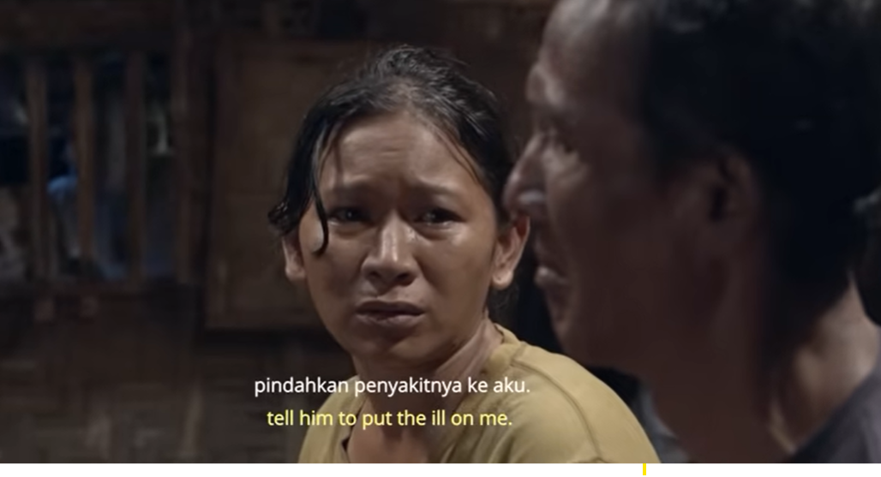
Figure 2. Marni asks Agus to have the shaman transfer Ningsih's illness to Marni.

The climax comes when Marni intends to hang herself and sacrifice herself as the seventh victim Agus is looking for. Marni begs her husband to kill her so that Ningsih can be cured of her illness. This is evident from Marni's dialogue with Agus:
" Aku wis ora kuat, mas. Mateni aku, mas! Aku kudu kepiye meneh, mas?! Kowe ojo pateni meneh wong, mas! Aku mung mati kanggo Ningsih!“
(I can't take it anymore, sir. Kill me, sir! What else can I do, sir?! Don't kill anyone else, sir! Let me die for Ningsih!).

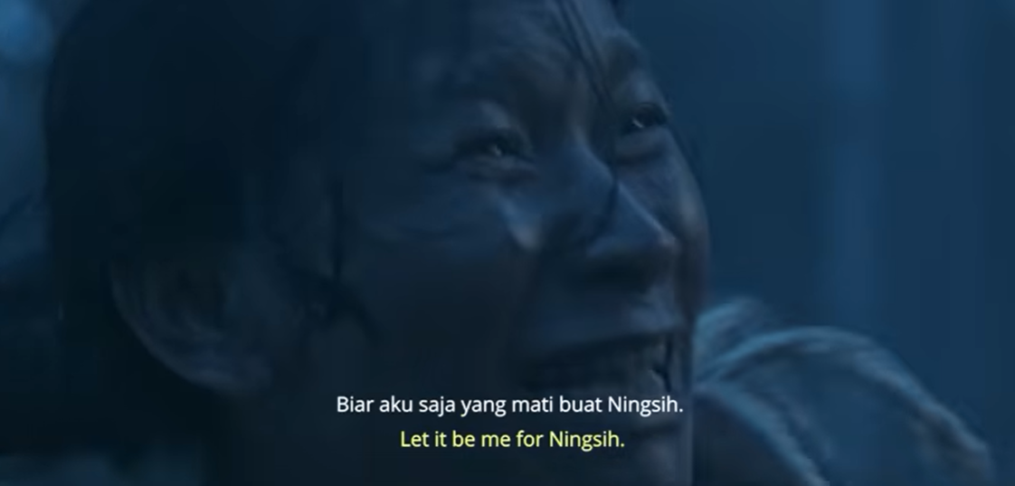
Figure 3. Marni asks Agus to kill her.

In the book Pulung Gantung, Darmaningtyas tells the story of Sukarto, a resident of Sekar Wangi Hamlet, Wonosari District, who chose to hang himself because his third child, Yanto, suffered from incurable cancer and his fourth child had a mental disorder. Sukarto sold his land for the sake of his children's recovery, but his hopes were not realized. On July 27, 1991, Sukarto was found by his wife hanging in the corner of his house.
The author concludes that there is optional intertextuality in both texts because of the similarity in the background of the suicides, namely having children who were sick and incurable, as well as economic pressure. However, the characters, such as the names and genders, in the short film Lamun Sumelang are not the same as the suicide perpetrators described in the book (Kristeva, 1980). In the short film Lamun Sumelang, Marni wants to commit suicide because she is desperate seeing Ningsih's suffering and Agus's difficulty in finding the seventh sacrifice. Meanwhile, in the book Pulung Gantung, Sukarto has sold all of his rice fields until he is like a person who is insane and ends up hanging himself.
The issue of poverty is shown in the mise-en-scène of the short film Lamun Sumelang in the elements of setting, costume, and makeup. In the mise-en-scène setting element, Agus's house is depicted as being made of bamboo and rattan, with a dirt floor, a kerosene lamp in front of the house, and Marni cooking using a stove and firewood. Crickets, jars, and flashlights at the beginning of the film are props used by Agus to catch crickets, which are a side dish for the sick Ningsih. It is known that the tradition of the Gunungkidul community is to catch crickets or other insects to sell as animal feed (livelihood) or to eat as a complement to staple foods (tradition or poverty).
The mise-en-scène elements of costume and makeup are depicted by the simple, dull, and worn-out clothes worn by Agus and his family. The mise-en-scène elements of staging, particularly the acting of the actors who play the characters Agus, Marni, and Ningsih, express the emotions, behavior, and psychology of the characters in depth so that the audience feels emotionally connected to the story and the characters being played. This is called conventional acting. The actors portray sadness, misfortune, and despair that can also be felt tangibly by the audience.

Living Alone
In the short film Lamun Sumelang, Mbah Parmin, a dead spirit character, interacts with Agus and expresses his frustration when Agus does not help him in his attempt to hang himself, but instead kills him by strangling him to death. The debate between Mbah Parmin and Agus ends with Mbah Parmin's implied statement about the loneliness of living alone in old age.
“Kowe ra tau reti rasane urip dhewe, aku kangen marang anakku.”
(You don't know what it's like to live alone. I miss my child).

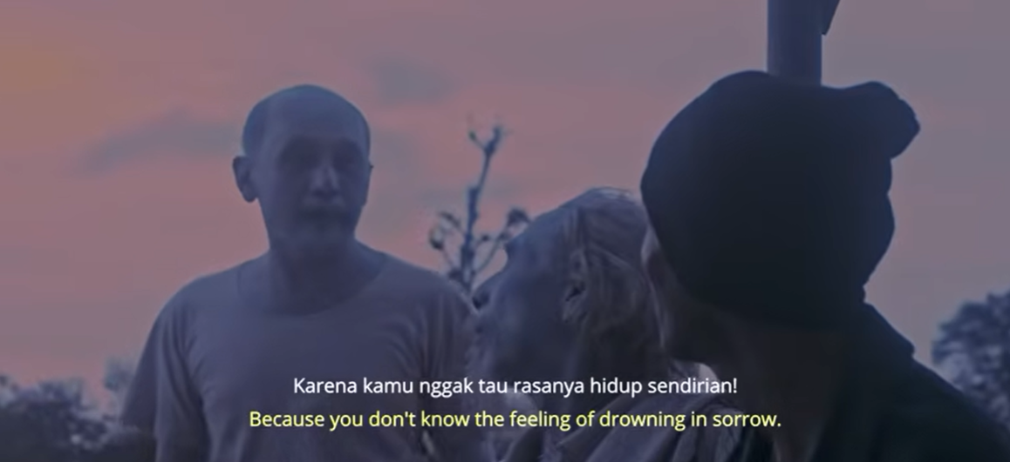
Figure 4. The spirit of Mbah Parmin is angry at Agus for killing him when he hanged himself.

In the film, it is mentioned that Mbah Parmin's child has not come home to visit him for a long time, leaving him feeling lonely because he lives alone. This statement is reinforced by the fact that many residents of Gunungkidul migrate in search of a better life (Jacobmeyer, 1998). The geographical location, which causes many rice fields to dry up, has led many young residents to seek their fortune in Yogyakarta or surrounding cities.
In the book Pulung Gantung, Darmaningtyas describes the case of Saliman alias Karto, a resident of Monggol Village, Saptosari District, who lives alone. He does not know where he comes from because he was separated from his family when he was a child while fleeing to safety during the Dutch attack on Yogyakarta (1948) or the Geger Lemper incident. After years of drifting, working for people who knew him out of pity, choosing not to marry and have children, suffering from unresolved trauma, mental illness, and severe eye disease, he could no longer bear his endless suffering. Finally, Saliman decided to commit suicide by hanging himself.
The author identifies the presence of optional intertextuality in both texts because they share similarities in the background or history of the characters, namely that they both live alone. However, in terms of character, such as name and gender, they are also different in the film Lamun Sumelang and the book Pulung Gantung. In the film Lamun Sumelang, Mbah Parmin is depicted as living alone, abandoned by his child who never came home to see him again, leaving him feeling lonely. Meanwhile, in the book Pulung Gantung, Saliman lives alone because he was separated from his parents in 1948. To show this, the mise-en-scène staging elements, especially the conventional acting of the actor who plays Mbah Parmin, support the expression of sadness due to living alone, abandoned by his child, and shown through his frustration when he is angry because he is killed by Agus.

Chronic Illness
In the film Lamun Sumelang, the character Mbah Sum intends to commit suicide because of chronic illness. The reason for this suicide is revealed when the spirits of the dead (supporting characters) talk to each other and Mbah Pon, his friend, reveals the background of Sum's death.
“Tekon o Mbak Sum ki lho, sing kulina kelaranen mbiyen.”
(Ask Mba Sum, who used to be sick often).
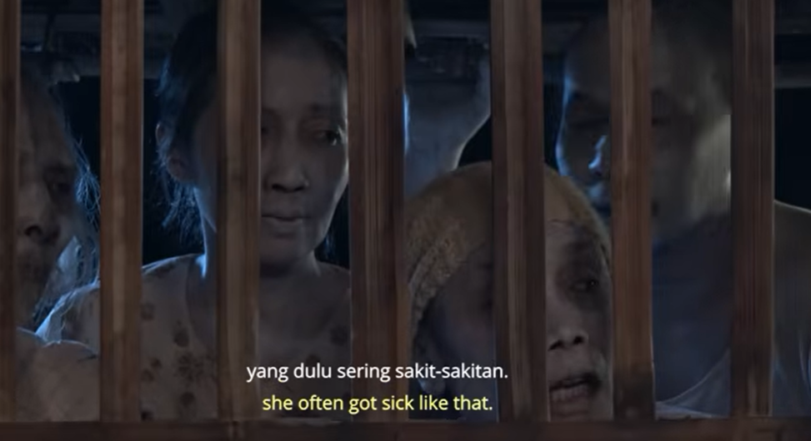
Figure 5. Mbah Pon reveals the background to Sum's death when he sees the miserable life of Agus's family.

Chronic illness is also depicted in the film through the character of Ningsih, who is sick, seen lying in bed, weak, and convulsing. Meanwhile, in the book Pulung Gantung, Darmaningtyas tells the story of Sidomejo, alias Pak Kromo, a resident of Cengkir Village, Tepus District, who suffers from asthma. Various medical and non-medical treatments have been tried, but to no avail; in fact, his condition has worsened. Suffering from asthma for 15 years, Sidomejo ended his life by hanging himself in his yard.
There is optional intertextuality in the short film Lamun Sumelang and the book Pulung Gantung, namely the issue of chronic illness suffered in both texts. However, the character in the short film Lamun Sumelang is not exactly the same as the suicide victim in the book Pulung Gantung (Ivanič, 1998). The mise-en-scène elements of staging, particularly the movements and acting (conventional acting) that portray the character Ningsih, can be seen in this film with her listless and sluggish expressions, as if she has no energy, and her movements during the scene where she has convulsions in bed.
The mise-en-scène elements of costume and make-up in the short film Lamun Sumelang depict the dead spirits (the characters Mbah Parmin, Mbah Sum, Mbah Pon, Mbah Jiman, Mr. Agus, and other spirits) with white faces and bodies, in contrast to the living (Agus, Marni, Ningsih before her death, and the other residents). This clearly shows the audience the difference between the living and the dead. The last scene in the film also depicts the film's sad ending, in which Ningsih is seen with her face and body painted white like the spirits of the dead, implicitly explaining that Ningsih did not recover but died.
The mise-en-scène elements of costume and other makeup in the short film Lamun Sumelang depict several dead spirits hanging by ropes around their necks. Several dead spirits are seen with ropes around their necks in the forest after Agus kills Mbah Parmin, and Agus's father is also seen in front of Agus's house with a rope around his neck. This represents those who have died by hanging themselves. There is intertextuality between the short film Lamun Sumelang and the book Pulung Gantung in relation to the use of the same tool for hanging oneself, namely a rope. In the book Pulung Gantung, not only is a rope used, but the evidence of hanging oneself is a setagen (a woman's cloth belt). According to Darmaningtyas (2002), the mode of suicide by hanging with rope or setagen is not dominated by the pulung gantung myth, but rather explains the simplicity of their lives or thoughts, seeking a solution using things that are around them. Almost every house has a setagen, so they do not need to spend money to commit suicide compared to using insecticide or pesticide.
Mise-en-scène lighting elements in the short film Lamun Sumelang related to the theme of suicide make this film have color grading or dark blue colors that describe a tense, unfortunate, sad, and ironic impression in life. The side light and hard light techniques, which show the emotional facial expressions of each character, also seem to reinforce the intentions and messages that the characters in the film want to convey.
Mise-en-scène staging elements such as gestures, eyes, and facial expressions are also played well by the actors in portraying each character in the film. Agus's gestures, for example, show him always on guard at the beginning of the film, looking for people who want to commit suicide so he can kill them, panicking when Ningsih has convulsions, and crying at the end of the film. Marni's gestures show her anxiety, despair, daydreaming, and crying when thinking about Ningsih's illness. Ningsih's gestures show her lethargy and illness. The eyes and facial expressions of the characters Agus, Marni, and Ningsih are almost the same, namely sad, tearful, pitiful, unfortunate, and sad. Meanwhile, another facial expression seen from the character Mbah Parmin is one of annoyance and anger when he is killed by Agus. Meanwhile, the dialogue used in the short film Lamun Sumelang is in Javanese language and dialect.

- CONCLUSION
The 2019 short film Lamun Sumelang by Ludy Oji Prastama and the 2002 book Pulung Gantung: Menyingkap Tragedi Bunuh Diri di Gunungkidul by Darmaningtyas are related to each other through optional intertextuality. Optional intertextuality occurs when a new work does not require knowledge of the previous work, but enriches the meaning if the reader or viewer is familiar with it. In addition, there are indications of intentionality in the selection of themes, motifs, and intersecting discourses.
In the short film Lamun Sumelang by Ludy Oji Prastama, which raises the themes of suicide, the cultural myth of pulung gantung, and social conditions in Gunungkidul, there is a clear alignment with the themes in the book Pulung Gantung: Uncovering the Suicide Tragedy in Gunungkidul by Darmaningtyas. If the audience of the short film Lamun Sumelang is already familiar with Darmaningtyas' analysis in the book Pulung Gantung regarding social determinants, structural poverty, and cultural myths, then their experience of watching the short film Lamun Sumelang can be enriched—but it is not necessary to understand the text in the book Pulung Gantung. Viewers can still enjoy the short film Lamun Sumelang without having to understand the book Pulung Gantung. The relationship between the short film and the book reveals thematic and discursive connections, rather than narrative dependencies that refer to dependence on the structure and plot of a narrative. The optional intertextuality between the two texts can be found in four aspects, namely the myth of pulung gantung, the issue of poverty or economic pressure, living alone in old age, and chronic illness.
Various aspects and elements of mise-en-scène in the short film Lamun Sumelang also support the explanation of the connection between the two texts. The mise-en-scène that most supports this short film is the aspects of setting, costume, and makeup. These supporting aspects further strengthen the depth and background of each character.
REFERENCES
Aragay, M. (2005). Books in Motion: Adaptation, Intertextuality, Authorship. Rodopi.
Bordwell, D., & Thompson, K. (2008). Film Art: An Introduction. McGraw Hill.
Darmaningtyas. (2002). Pulung gantung: menyingkap tragedi bunuh diri di Gunungkidul. Salwa Press.
Fatimah, S. (2025, October). Kasus Bunuh Diri di DIY Naik 20%, Gunung Kidul Paling Banyak. Tirto.Id.
Fitzsimmons, J. (2013). Romantic and Contemporary Poetry: Readings. CQUniversity.
Iampolski, M. (1998). The Memory of Tiresias: Intertextuality and Film. University of California Press.
Ivanič, R. (1998). Writing and Identity: The Discoursal Construction of Identity in Academic Writing. John Benjamins Publishing Company. https://doi.org/10.1075/swll.5
Jacobmeyer, H. (1998). Graham Swift, Ever After : a Study in Intertextuality. Gwdg.De.
Kristeva, J. (1980). Desire in Language: A Semiotics Approach to Language and Art. Columbia University Press.
Kristeva, J. (1986). Word, Dialogue and the Novel. In The Kristeva Reader (pp. 35–61). Columbia University Press.
Raj, P. (2015). Text/Texts: Julia Kristeva’s Concept of Intertextuality. Ars Artium, 3.
Sagita, N. S. (2025, October). Provinsi Ini Catat Kasus Bunuh Diri Terbanyak di Indonesia. Detik.Com.
Sukmadinata, N. S. (2011). Metode penelitian pendidikan. Remaja Rosdakarya.

